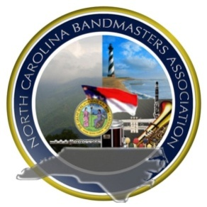NCBA Southeastern District

Music Performance Adjudication Enrollment Form

The undersigned hereby makes application to enter

Click here to enter text.

**School Name and Band (i.e. Symphonic Band, Concert Band,Wind Ensemble)**

in the NCBA Southeastern District **Music Performance Adjudication** to be held at Jack Britt High School in Fayetteville, North Carolina on March 31-April 2, 2020. Enclosed is this year’s registration fee, a check for $225.00, made payable to **SEDBA.**

**Performance Repertoire**

|  |  |  |
| --- | --- | --- |
|  | Title | Composer |
| March | Click here to enter text. | Click here to enter text. |
| First Selection | Click here to enter text. | Click here to enter text. |
| Second Selection | Click here to enter text. | Click here to enter text. |

**DIRECTOR/SCHOOL ADMINISTRATOR APPROVAL**

I have carefully read the NCMEA Music Performance Adjudication Rules and Regulations and will be guided thereby.

**Band Director’s Signature:**  **Date:**

**CERTIFICATE OF ELIGIBILITY**

I hereby certify that all students enrolled from this school to appear in the District Music Performance Adjudication are eligible according to the regulations of eligibility.

**Principal’s Signature:**  **Date:**

This form must be mailed to the **Music Performance Adjudication Chairman, Jamie Bream** (22801 Airbase Rd. - Laurinburg, NC 28352), and must be postmarked no later than thirty days prior to the first day of the Music Performance Adjudication, **Feb 28th 2020.**

**DEADLINES WILL BE STRICTLY ENFORCED.**

|  |  |
| --- | --- |
| **For MPA Chairman’s Use Only** | |
| **CHECK #** |  |
| **DATE PAID** |  |